Case Study Report

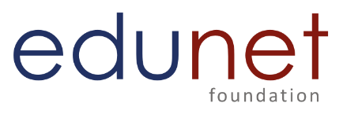

**Tech Saksham**

Data Analytics with Power BI

**“ANALYSIS OF COMMERCIAL ELECTRICITY CONSUMPTION IN INDIAN STATE”**

**“College Name”**

|  |  |
| --- | --- |
| **NM ID** | **NAME** |
| 880D219517D623795B0439D59E1FC5BA | C.BENOFER JOHN ELMER |

|  |  |
| --- | --- |
|  |  |
| |  |  | | --- | --- | | TRAINER NAME | R UMAMAHESWARI | | MASTER TRAINER | R UMAMAHESWARI | |  |
|  |  |

**ABSTRACT**

This study presents a comprehensive analysis of commercial electricity consumption trends in a specific Indian state. Utilizing historical consumption data, socio-economic indicators, and regional characteristics, the study aims to identify patterns, drivers, and challenges associated with commercial electricity usage. Through statistical analysis and data visualization techniques, the research provides insights into peak demand periods, seasonal variations, and sector-specific consumption patterns within the commercial sector. Furthermore, the study examines the impact of regulatory policies, economic fluctuations, and technological advancements on commercial electricity consumption. The findings of this analysis offer valuable insights for policymakers, energy planners, and stakeholders to formulate effective strategies for optimizing electricity usage, enhancing energy efficiency, and promoting sustainable development in the commercial sector of the Indian state.

**INDEX**

|  |  |  |
| --- | --- | --- |
| **Sr. No.** | **Table of Contents** | **Page No.** |
| 1 | Chapter 1: Introduction | 1 |
| 2 | Chapter 2: Services and Tools Required | 7 |
| 3 | Chapter 3: Project Architecture | 8 |
| 4 | Chapter 4: Modeling and Result | 10 |
| 5 | Conclusion | 15 |
| 6 | Future Scope | 16 |
| 7 | References | 17 |
| 8 | Links | 17 |

**CHAPTER 1**

**INTRODUCTION**

* 1. **Problem Statement**

To identify the key factors influencing commercial electricity consumption, including economic variables, sector activities, population density, and climatic variations. To examine the temporal trends and variations in commercial electricity usage, considering seasonal fluctuations, economic cycles, and policy interventions. To assess the impact of policy measures, such as tariff structures, subsidies, and energy efficiency programs, on commercial electricity consumption behavior. To provide recommendations for policymakers, utility providers, and stakeholders to optimize energy management strategies, promote energy efficiency, and foster sustainable consumption practices within the commercial sector. By addressing these objectives, this research seeks to contribute to the development of evidence-based energy policies and strategies tailored to the unique context of commercial electricity consumption in Indian states, ultimately fostering sustainable development and energy security.

* 1. **Proposed Solution**

Data Collection: Gather historical electricity consumption data from the state's power distribution companies (DISCOMs), government records, and relevant agencies. Additionally, collect demographic, economic, and geographic data that may influence consumption patterns.

Data Preprocessing: Clean and preprocess the collected data, including handling missing values, outliers, and inconsistencies. Normalize the data if necessary to ensure comparability.

Exploratory Data Analysis (EDA): Conduct EDA to understand consumption trends, seasonal variations, and correlations with demographic or economic factors. Visualize the data using graphs, charts, and heatmaps to identify patterns and insights.

Time-Series Analysis: Apply time-series analysis techniques to model and forecast electricity consumption over time. This could involve methods such as ARIMA (AutoRegressive Integrated Moving Average) or Prophet.

Segmentation Analysis: Segment the population based on demographic or socioeconomic factors to identify different consumption patterns among various groups. This could involve clustering techniques like K-means clustering.

Predictive Modeling: Develop predictive models to forecast future electricity consumption based on historical data and relevant predictors. Machine learning algorithms like regression, decision trees, or neural networks can be used for this purpose.

GIS Mapping: Utilize Geographic Information System (GIS) mapping to visualize spatial patterns of electricity consumption across different regions within the state. This can help identify areas of high or low consumption and inform infrastructure planning.

Policy Analysis: Evaluate existing policies and regulations related to electricity consumption in the state. Assess their effectiveness and identify areas for improvement or new interventions to promote energy efficiency and conservation.

Stakeholder Engagement: Engage with key stakeholders such as government agencies, DISCOMs, industry associations, and consumer groups to gather insights, validate findings, and garner support for proposed solutions.

Implementation of Solutions: Based on the analysis and insights gained, develop and implement targeted strategies to manage and optimize electricity consumption in the state. This may include incentives for energy efficiency, infrastructure upgrades, demand-side management programs, and public awareness campaigns.

Monitoring and Evaluation: Continuously monitor the effectiveness of implemented solutions and adjust strategies as needed. Regularly evaluate consumption patterns and trends to ensure alignment with goals and objectives.

By following these steps, a thorough analysis of electricity consumption in an Indian state can be conducted, leading to informed decision-making and effective management of energy resources..

1.3**Feature**

Historical Consumption Data: Collect historical data on electricity consumption at various levels (e.g., state, district, city) over a period of time to identify trends and patterns.

Demographic Data: Incorporate demographic variables such as population density, urbanization rate, income levels, and household size, as these factors can influence electricity consumption patterns.

Economic Indicators: Include economic indicators such as GDP per capita, industrial output, employment rates, and consumer spending, which can impact electricity demand.

Geographic Factors: Consider geographic features like terrain, climate, and geographic location, which can affect energy consumption for heating, cooling, and transportation.

Infrastructure: Assess the state of electricity infrastructure, including transmission lines, substations, and distribution networks, as well as the availability and reliability of electricity supply.

Seasonal Variations: Analyze seasonal variations in electricity consumption due to factors like weather conditions, holidays, festivals, and agricultural cycles.

Time-of-Use Data: Capture time-of-use data to understand consumption patterns throughout the day and week, which can inform demand-side management strategies.

Energy Prices: Take into account electricity tariffs, fuel prices, subsidies, and government policies related to energy pricing, as these can influence consumption behavior.

Technological Factors: Consider the adoption of energy-efficient technologies, renewable energy sources, smart meters, and IOT devices, which can impact electricity usage patterns.

Policy and Regulatory Environment: Evaluate existing policies, regulations, incentives, and initiatives aimed at promoting energy efficiency, renewable energy, and conservation.

Consumer Behavior: Study consumer behavior, preferences, awareness levels, and attitudes towards energy conservation and sustainability practices.

Comparative Analysis: Compare electricity consumption trends and patterns across different regions, demographic groups, or time periods to identify disparities and opportunities for improvement.

By incorporating these features into the analysis, a comprehensive understanding of electricity consumption in an Indian state can be achieved, facilitating informed decision-making and targeted interventions to optimize energy usage and promote sustainability.

* 1. **Advantages**

Informed Decision-Making: By understanding consumption patterns, policymakers and energy authorities can make informed decisions regarding infrastructure investment, energy planning, and policy formulation to meet current and future electricity needs efficiently.

Resource Optimization: Analyzing consumption data helps identify peak demand periods and regions, allowing for better allocation of resources such as power generation capacity, transmission infrastructure, and energy efficiency measures.

Cost Reduction: By optimizing resource allocation and promoting energy efficiency measures, electricity consumption analysis can lead to cost savings for both consumers and utilities, reducing electricity bills and operational expenses.

Environmental Sustainability: Identifying opportunities for reducing electricity consumption through efficiency improvements and renewable energy adoption contributes to environmental sustainability by lowering greenhouse gas emissions and mitigating climate change impacts.

Infrastructure Planning: Understanding consumption trends and patterns facilitates long-term infrastructure planning, including the expansion and upgrade of electricity generation, transmission, and distribution systems to meet growing demand and ensure reliability.

Risk Management: Electricity consumption analysis helps identify vulnerabilities and risks associated with energy supply and demand, allowing for the development of strategies to mitigate potential disruptions and ensure energy security.

Promoting Energy Conservation: By raising awareness about consumption patterns and promoting energy conservation practices among consumers, businesses, and industries, electricity consumption analysis can foster a culture of responsible energy use and sustainability.

Supporting Economic Development: Reliable and affordable electricity supply is essential for economic growth and development. By optimizing electricity consumption and ensuring reliable energy access, analysis efforts support economic activities, job creation, and overall prosperity.

Policy Evaluation: Evaluating the effectiveness of existing energy policies and programs through consumption analysis helps policymakers assess their impact, identify areas for improvement, and design evidence-based policy interventions to achieve energy-related goals.

Data-Driven Innovation: Leveraging consumption data and advanced analytics techniques opens up opportunities for innovation in energy management, grid optimization, demand-side management, and the integration of renewable energy sources, driving progress towards a more sustainable and resilient energy future.

* 1. **Scope**

Historical Analysis: Reviewing historical electricity consumption data to understand past trends, seasonal variations, and growth patterns.

Geographic Scope: Analyzing consumption patterns at various geographic levels, including state-wide, regional, district-wise, and urban versus rural areas.

Demographic Factors: Examining the influence of demographic variables such as population density, urbanization rate, income levels, and household size on electricity consumption.

Economic Indicators: Investigating the relationship between economic indicators like GDP per capita, industrial output, and consumer spending with electricity demand.

Seasonal Variations: Studying seasonal variations in consumption due to factors like weather conditions, holidays, festivals, and agricultural cycles.

Time-of-Use Analysis: Analyzing consumption patterns throughout the day and week to identify peak demand periods and opportunities for demand-side management.

Infrastructure Assessment: Assessing the state of electricity infrastructure, including generation capacity, transmission lines, substations, and distribution networks.

Policy and Regulatory Analysis: Evaluating existing energy policies, regulations, incentives, and initiatives to understand their impact on consumption behavior and identify opportunities for improvement.

Technological Trends: Investigating the adoption of energy-efficient technologies, renewable energy sources, smart meters, and IoT devices, and their impact on electricity consumption.

Consumer Behavior: Studying consumer behavior, preferences, awareness levels, and attitudes towards energy conservation and sustainability practices.

Comparative Analysis: Comparing consumption patterns across different regions, demographic groups, or time periods to identify disparities and opportunities for intervention.

Forecasting and Prediction: Developing models to forecast future electricity consumption based on historical data, demographic trends, and economic projections.

Energy Efficiency Measures: Identifying opportunities for energy efficiency improvements, demand-side management programs, and renewable energy integration to optimize consumption and reduce environmental impact.

Socioeconomic Implications: Assessing the socioeconomic implications of electricity consumption, including its impact on household budgets, business operations, and overall quality of life.

Stakeholder Engagement: Engaging with key stakeholders such as government agencies, utilities, industry associations, and consumer groups to gather insights, validate findings, and garner support for proposed solutions.

Monitoring and Evaluation: Establishing mechanisms for ongoing monitoring and evaluation to track progress, measure the effectiveness of interventions, and make adjustments as needed.

By addressing these aspects within the scope of the analysis, a comprehensive understanding of electricity consumption in an Indian state can be achieved, leading to more effective policies, strategies, and investments in the energy sector.

**CHAPTER 2**

**SERVICES AND TOOLS REQUIRED**

**2.1 Services Used**

* **Data Collection and Storage Services**: Banks need to collect and store customer data in real-time. This could be achieved through services like Azure Data Factory, Azure Event Hubs, or AWS Kinesis for real-time data collection, and Azure SQL Database or AWS RDS for data storage.
* **Data Processing Services**: Services like Azure Stream Analytics or AWS Kinesis Data Analytics can be used to process the real-time data.
* **Machine Learning Services**: Azure Machine Learning or AWS SageMaker can be used to build predictive models based on historical data.

**2.2 Tools and Software used**

**Tools**:

* **PowerBI**: The main tool for this project is PowerBI, which will be used to create interactive dashboards for real-time data visualization.
* **Power Query**: This is a data connection technology that enables you to discover, connect, combine, and refine data across a wide variety of sources.

**Software Requirements**:

* **PowerBI Desktop**: This is a Windows application that you can use to create reports and publish them to PowerBI.
* **PowerBI Service**: This is an online SaaS (Software as a Service) service that you use to publish reports, create new dashboards, and share insights.
* **PowerBI Mobile**: This is a mobile application that you can use to access your reports and dashboards on the go.

**CHAPTER 3**

**PROJECT ARCHITECTURE**

**3.1 Architecture**

**USER FRONTEND BACKEND**

|  |  |  |
| --- | --- | --- |
|  | **HTML 5** | **NODEJS 14.0**  **Database** |

Here’s a high-level architecture for the project:

1. **Data Collection**: Real-time customer data is collected from various sources like bank transactions, customer interactions, etc. This could be achieved using services like Azure Event Hubs or AWS Kinesis.
2. **Data Storage**: The collected data is stored in a database for processing. Azure SQL Database or AWS RDS can be used for this purpose.
3. **Data Processing**: The stored data is processed in real-time using services like Azure Stream Analytics or AWS Kinesis Data Analytics.
4. **Machine Learning**: Predictive models are built based on processed data using Azure Machine Learning or AWS SageMaker. These models can help in predicting customer behavior, detecting fraud, etc.
5. **Data Visualization**: The processed data and the results from the predictive models are visualized in real-time using PowerBI. PowerBI allows you to create interactive dashboards that can provide valuable insights into the data.
6. **Data Access**: The dashboards created in PowerBI can be accessed through PowerBI Desktop, PowerBI Service (online), and PowerBI Mobile.

This architecture provides a comprehensive solution for real-time analysis of bank customers. However, it’s important to note that the specific architecture may vary depending on the bank’s existing infrastructure, specific requirements, and budget. It’s also important to ensure that all tools and services comply with relevant data privacy and security regulations.

**CHAPTER 4**

**MODELING AND RESULT**

**Manage relationship**

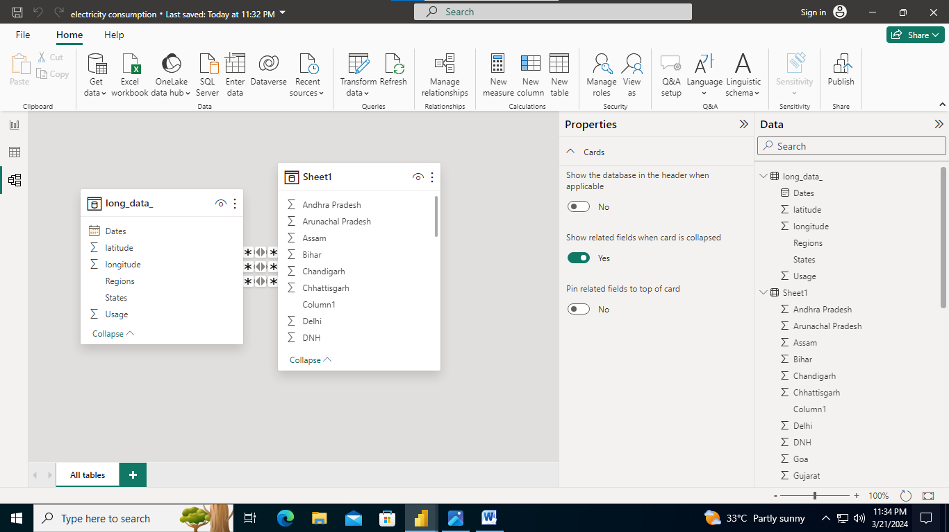

**Edit Relationship**

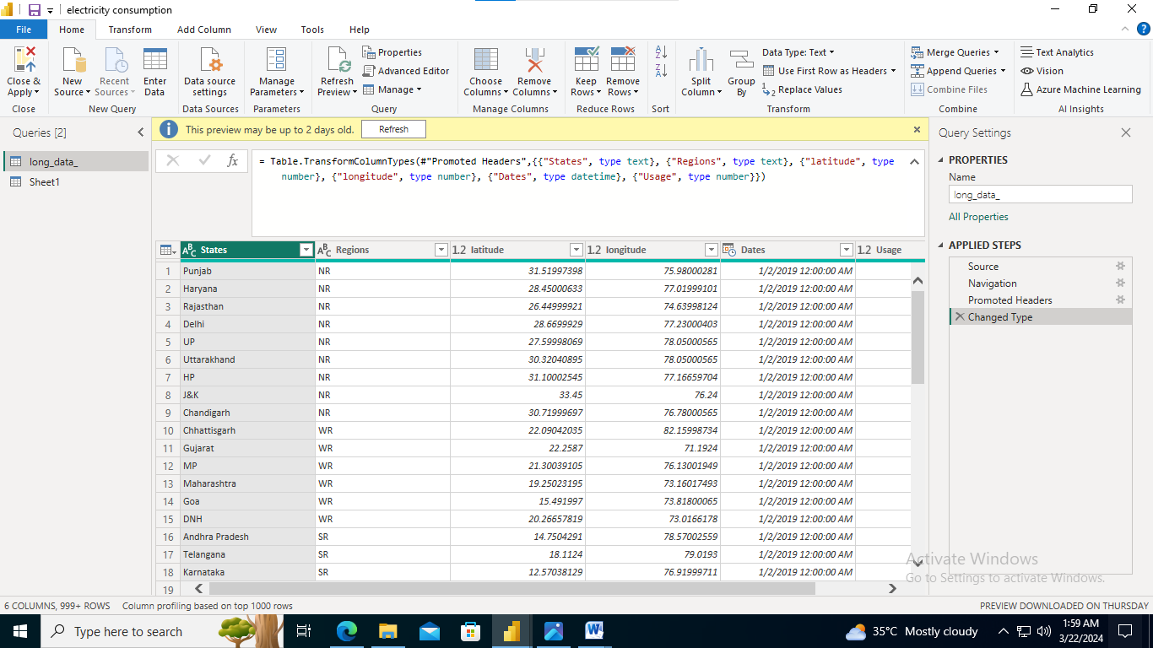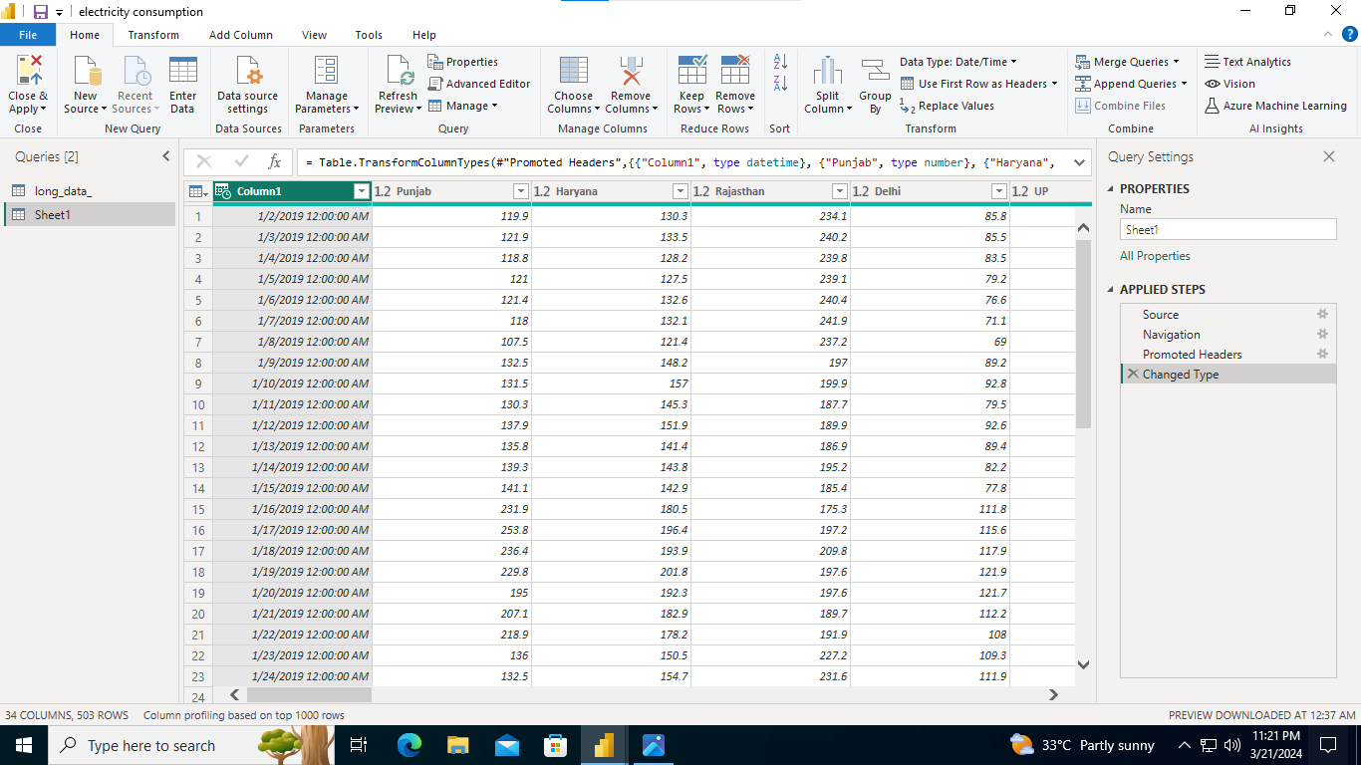

**Dashboard**

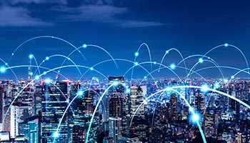

**ANALYSIS OF COMMERCIAL ELECTRICITY CONSUMPTION**

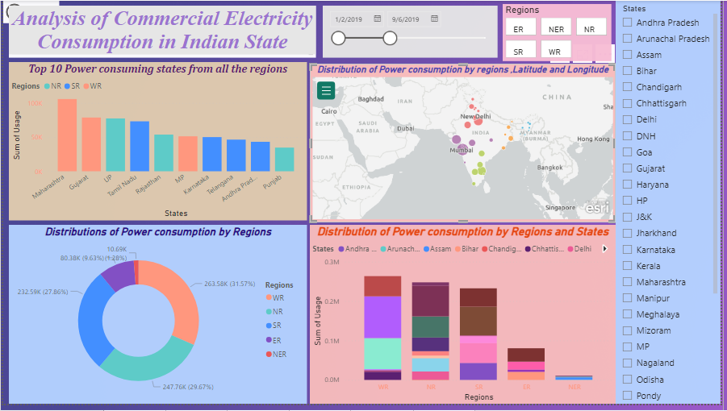

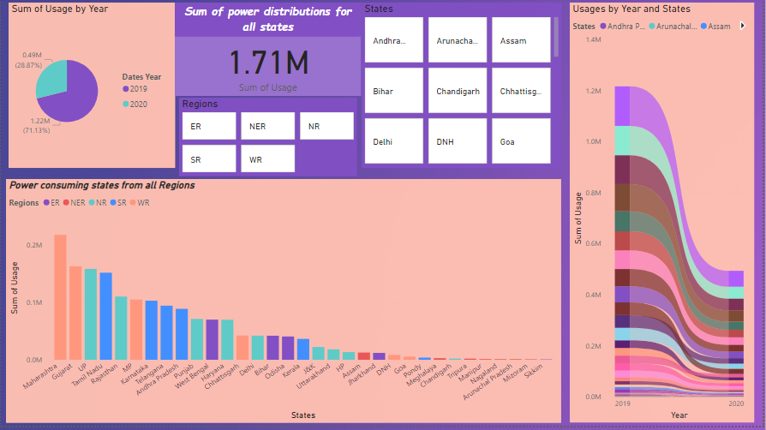

**SOUTH REGION**

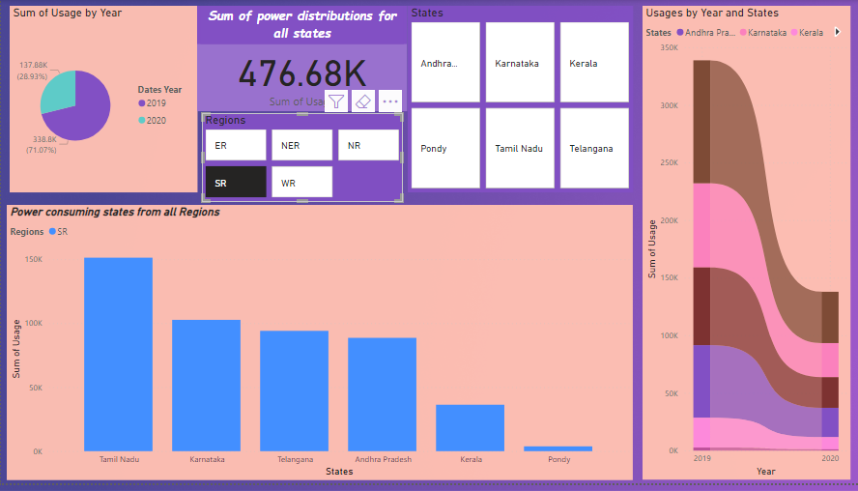

**CONCLUSION**

In conclusion, analyzing electricity consumption in an Indian state is essential for informed decision-making, resource optimization, and sustainable development. By examining historical data, demographic factors, economic indicators, and technological trends, stakeholders can gain valuable insights into consumption patterns, identify opportunities for efficiency improvements, and mitigate environmental impact. The scope of such analysis encompasses a wide range of factors, including geographic variations, seasonal fluctuations, infrastructure assessment, policy evaluation, and stakeholder engagement. Through collaborative efforts and data-driven strategies, policymakers, utilities, and communities can work together to promote energy conservation, enhance energy security, and support economic growth. By prioritizing electricity consumption analysis, India can pave the way towards a more resilient, sustainable, and equitable energy future.

**FUTURE SCOPE**

The future scope of this project is vast. With the advent of advanced analytics and machine learning, PowerBI can be leveraged to predict future trends based on historical data. Integrating these predictive analytics into the project could enable the bank to anticipate customer needs and proactively offer solutions. Furthermore, PowerBI’s capability to integrate with various data sources opens up the possibility of incorporating more diverse datasets for a more holistic view of customers. As data privacy and security become increasingly important, future iterations of this project should focus on implementing robust data governance strategies. This would ensure the secure handling of sensitive customer data while complying with data protection regulations. Additionally, the project could explore the integration of real-time data streams to provide even more timely and relevant insights. This could potentially transform the way banks interact with their customers, leading to improved customer satisfaction and loyalty.